Consumer-mediated nutrient cycling across latitudes

Em G Lim¹ and Isabelle M Côté¹

Affiliations
¹Biological Sciences, Simon Fraser University, Vancouver, British Columbia, CAN

Corresponding author: Em Lim (ORCiD: 0000-0002-3586-2108), em.g.lim13@gmail.com

Abstract
Consumer-mediated nutrient cycling (CNC) refers to metabolic waste products of animals that can fertilize and bolster primary productivity. Despite the widespread assumption that CNC is less important in nutrient-rich temperate waters, empirical tests for global-scale patterns of CNC effects on primary producers are lacking. Here, we conducted a meta-analysis of published literature to assess the effects of animal-provisioned nutrients on primary productivity in marine ecosystems. We identified 41 suitable studies, from which we calculated effect sizes as response ratios of productivity of provisioned vs unprovisioned systems. We quantified and compared the effect sizes reflecting the growth benefit of CNC to primary producers between temperate and tropical regions, considering latitude, temperature, and external nutrients. Our results show no difference in the effect of CNC on primary productivity between temperate vs tropical regions, contradicting the prevailing ecological paradigm. This suggests that the effects of CNC on primary producers may be driven by smaller-scale processes that are not generalizable across broad regions.

Overview for intro:
- Bottom-up processes are super important. Different systems have different limiting nutrients. Needs of pp dictate how important provisioning is
- Animals contribute to bottom up processes. CND.
- CND super cool in the ocean? Nitrogen is limiting. External sources of nitrogen. Internal sources of nitrogen. Animals represent the largest pool of nutrients, so they dictate the rate of cycling.
- Theory states that provisioning is less important when nutrients are abundant, but there’s some exceptions (complementary timing, ideal ratio of delivery, bioavailable form). State the conventional wisdom assumption here.
- In this study…

Introduction
Although anthropogenic eutrophication has had some catastrophic effects across terrestrial and aquatic ecosystems (Smith et al., 1999), nutrient enrichment remains an important process in supporting primary productivity and thus ecosystem structure. Provisioning of nitrogen, phosphorus, and other limiting elements can produce dramatic increases in primary productivity beyond Net Primary Productivity across ecosystems (Gough et al., 2016). However, nutrient provisioning is important only relative to the nutrient demands of the primary producer. For example, tropical tree species show variable responses to nitrogen enrichment, but consistently positive responses to phosphorus (Fortier and Wright, 2021). The impact of provisioning also depends on the availability of nutrients in the system; phosphorus enrichment famously causes algae blooms in lakes, while nitrogen fails to produce a similar bloom when added in isolation (Schindler, 1974). In rainforests, seedlings adapted to nutrient-poor soil are limited in their response to fertilization, but seedlings from nutrient-rich soil which respond strongly to fertilization (Zalamea et al., 2016). Finally, even the form and relative amounts of the supplied nutrients is important. In general, the addition of nitrogen and phosphorus in combination produces the largest increase in primary productivity across systems (Elser et al., 2007), although non-additive effects are common (Allgeier et al., 2011).

Although consumers are often assumed to mediate primary productivity through “top-down” effects, e.g. herbivory, they can also mediate “bottom-up” processes through metabolic nutrient release (Allgeier et al., 2017). Nutrient provisioning by consumers via excretion or egestion, henceforth termed consumer-mediated nutrient cycling (CNC), has been shown to substantially affect primary productivity and community functioning in aquatic (Atkinson et al., 2017; Vanni, 2002), terrestrial (McNaughton et al., 1988; Sitters et al., 2017), tropical (Meyer et al., 1983; Peterson and Heck, 2001) and some temperate (Bracken et al., 2007; Pfister et al., 2014) marine ecosystems. CNC refers both to the storage and cycling of nutrients through animal tissues, processes which are governed by stoichiometry (Elser and Urabe, 1999) and metabolic rates (REF). Scaling up from the individual to the population or community level can be challenging, but in general the amount of CNC depends on the biomass and diversity of the total community of animals in a system (Allgeier et al., 2017).

In marine ecosystems nitrogen is the dominant limiting nutrient for primary producers (Ryther and Dunstan, 1971), which contrasts with terrestrial and freshwater ecosystems, which are co-limited by phosphorus and nitrogen (Elser et al., 2007). Specifically, the growth of many species of algae (Jackson, 1977), seagrasses (Hillman et al., 1989), and phytoplankton (Moore et al., 2013) is limited by the availability of inorganic nitrogen, both exogenous and endogenous. Exogenous nitrogen sources can profoundly affect marine primary productivity (Probyn and McQuaid, 1985; Smith et al., 1999). Coastal upwelling – the delivery to the surface of deep nutrient-rich waters via offshore winds– can be an important source of nitrogen that drives the productivity of temperate marine ecosystems (McPhee-Shaw et al., 2007). Two external terrestrial sources – natural weathering of rocks and agricultural run-off – also supply nutrients to nearshore marine ecosystems (CITE). However, upwelling, terrestrial input, and agricultural run-off supply nitrogen in the form of nitrates (NO₃⁻) which requires metabolic conversion by plants and algae before use (Probyn and McQuaid, 1985; Smith et al., 1999). In contrast, some animals, such as fishes and invertebrates, also contribute nitrogen (e.g. via excretion) in the form of ammonium (NH₄⁺), which is available for direct uptake and is thus preferred (Phillips and Hurd, 2004). Therefore, excretion by marine animals represents an important endogenous source of nutrients in marine ecosystems (Allgeier et al., 2017). Further, marine animals represent the largest pool of standing biomass, so their processes dictate the rate of internal nutrient cycling. Consequently, the total available nitrogen content in marine systems can dictate trophic energy transfer, and therefore total ecosystem biomass, mainly through bottom-up processes.

There is a widespread, although untested, assumption that the effect of CNC should be largest in ecosystems with low external nutrient input, such as on coral reefs (REF). However, several lines of evidence do not support this assumption. CNC has been shown to significantly bolster primary productivity in some areas with high external nutrient input, such as those frequently found in temperate latitudes. For example, Pfister et al. (2014) found that animal-derived ammonium contributed more to the overall nitrogen budget of a temperate rocky reef ecosystem than nitrates from upwelling. In temperate tidepools that are isolated from the ocean for extended periods of time, CNC can prevent nutrient depletion and support continuous productivity (Bracken, 2004). Further, in high-nutrient upwelling systems, the delivery of nitrates may be mismatched with the timing of summer productivity (Jackson, 1977; McPhee-Shaw et al., 2007), necessitating alternative nutrient sources in the summer (Brzezinksi et al., 2013). Finally, even when nitrates are abundant, ammonium is more readily taken up by primary producers (Phillips and Hurd, 2004). Consumer-mediated nutrients might therefore be an overlooked source of nitrogen that drives bottom-up processes in temperate systems. Empirical tests for global-scale patterns of CNC effects on primary producers are currently lacking.

In this study, we assessed the effects of animal-provisioned nutrients on primary productivity in different marine ecosystems, and specifically test whether these effects are more marked in nutrient-poor environments. By conducting a systematic review and meta-analysis of published literature, we sought to quantify and compare the extent to which animal-mediated nutrient provisioning bolsters primary productivity in temperate and tropical regions. Our results strengthen our understanding of consumers in mediating not just top-down processes, but also bottom-up processes on a global scale. Further, we hope this work will highlight the often-overlooked role of animals in marine nutrient dynamics.

Methods
Literature search and article screening
We conducted a systematic review and meta-analysis of existing literature to investigate the effect of animal-provisioned nutrients on marine primary producers. We identified five key elements that needed to appear in a paper for consideration: (1) marine habitat, (2) nutrients, (3) excretion or egestion (4) primary producers, and (5) a measured response. For each element we generated search terms of analogous and synonymous words (S1 for full search string). We conducted two consecutive searches, first from 1900 - August 13, 2020, then from August 14, 2020 – January 3, 2022, using the same search strings and limits. The last day of each interval was the day the search was performed. We searched the Web of Science Core Collection (Web of Science) and Aquatic Sciences and Fisheries Abstracts (ProQuest) databases and added two papers from our personal files. In Web of Science, our search yielded 1,257 publications. We refined this list by only including articles and proceedings papers to filter out unreviewed articles, which narrowed the results to 1,164 publications. We then removed publications that were not included in the Web of Science categories: Marine Freshwater Biology, Environmental Engineering, Ecology, Oceanography, Zoology, Environmental Studies, Limnology, Multidisciplinary Sciences, Biology, Plant Sciences, Fisheries, or Biodiversity Conservation, to remove studies outside of our field, which were generally not relevant, resulting in 1,006 publications. We supplemented this list by conducting a search in the database of Aquatic Sciences and Fisheries Abstracts using the same search string. This second search resulted in 1,428 publications, which narrowed to 1,169 publications once we included only published literature. We excluded the subjects: freshwater, bacteria, aquaculture, lakes, rivers, cyanobacteria, biogeochemistry, and nitrogen fixation to further narrow the results to 784 publications. We merged these two searches and removed duplicates (using revtools::find_duplicates() in R), resulting in 1,429 publications.

Each record had to meet the following criteria to be included: 1) the study was conducted in the marine environment, 2) animals were the primary contributors of manipulated or observed nutrient levels, 3) the response of primary producers to this nutrient provisioning was measured in terms of growth, abundance, weight, etc , and 4) the study reported all necessary information required to calculate an effect size of animal-provisioned nutrients on primary productivity. We first scanned all titles and abstracts of publications to determine if the articles met our criteria. Next, we combined the screening of the full texts with data extraction. If the publication met all criteria we extracted meta-data and calculated effect sizes from these publications.

Data extraction
We extracted the mean, standard deviation, and sample size for both the unprovisioned control and the provisioned treatment to calculate effect sizes as log-transformed response ratios (see below). When studies included multiple treatment levels, we only compared control and maximum treatment levels. For time series data we considered growth achieved between the first and last measurements. When instantaneous measurements (e.g. oxygen production) were made at multiple time points we included all time points. When data were only available in graph form, we used the program WebPlotDigitizer (https://automeris.io/WebPlotDigitizer/) to extract the means and standard deviations. When standard errors or confidence intervals were provided, we calculated standard deviations from these values. In some cases, we were unable to extract the mean and standard deviation from the publication and used the provided raw data to compute these values ourselves.

We also extracted information on the study location (latitude, longitude, water temperature, background nutrient availability), the experimental design, animal species or groups that provided the nutrients, the primary producer species or groups measured and the types of responses measured, and when the study occurred. We used the latitude and longitude provided by the authors to identify the study location and took the absolute latitude to reflect the distance of each study site from the equator. When coordinates weren’t provided we extrapolated them from named study locations, and when multiple study coordinates were provided, we used the latitude and longitude of the study site nearest to the center of the rest. We estimated mean water temperature during the experiments from data reported in the publications, and extrapolated temperature from published values at the same study site when the data was not presented in the original text (n = 20, TABLE S1). We classified background nutrient levels as the total nitrogen present in the ambient or control treatment, which could include any combination of nitrate, nitrite and ammonium. When this data was not reported (n = 19), we found published values of background nutrient levels recorded at the same location (TABLE S2). We also recorded the author’s characterization of the nutrient availability at their study site and ensured the proxy sites chosen matched these descriptions. We scored each experiment’s experimental design on a scale of 1-5; (1) Field: natural experiment, (2) Field: primary producer stocked, (3) Field: animal stocked, (4) Field: both primary producer and animals stocked, and (5) Mesocosm: lab experiment. Primary producers were grouped into either (1) macroalgae, (2) corals, (3) phytoplankton, or (4) vascular plants. Animals were grouped into (1) vertebrates, (2) mobile invertebrates, or (3) sessile invertebrates.

Data analysis
We examined latitude, temperature, background nutrient concentration, experimental design, and primary producer taxa as potential moderators of the effect of animal-mediated nutrient provisioning. We considered grouping primary producers into finer taxonomic levels (e.g., splitting fleshy and crustose algae, or seagrass and mangroves) but preliminary models with these finer groupings did not improve model fit, and we did not detect significant differences between finer groups within our chosen broader categories. We also investigated the effect of the consumer’s taxa or activity level but there were no subgroup differences and inclusion of this did not improve the model. We also collected data quantifying the level (i.e., nitrogen concentration) of provisioning by animals to primary producers, but this information was unavailable for most studies and inclusion did not improve model fit, so we did not consider this factor in final models.
We calculated effect sizes as log-transformed response ratios using the R function metafor::escalc, which computes effect size as the log of the treatment mean divided by the control mean. Effect sizes cannot be calculated for mean values less than or equal to zero (n = 9), so these were excluded. We standardized the continuous moderators (absolute latitude, temperature, and background nutrients) in the models to make the parameter estimates comparable. We determined that absolute latitude, temperature, and background nutrients were correlated using a correlation matrix (metaphor::vif), with VIF values of 6.04, 4.80, and 3.73 respectively. Therefore, we were unable to include all three moderators in the same model.

We constructed three three-level mixed-effects models (metafor::rma.mv) including only one of the correlated moderators (absolute latitude, temperature, or background nutrients) and both categorical moderators (experimental design and primary producer taxa) and a random effect of individual effect size nested within publication (random = ~ 1 | paper /individual_effect_size). As some studies contributed multiple effect sizes, this nested structure accounted for non-independence among our effect sizes (Viechtbauer, 2010). We compared the three models against a null model using Akaike’s Information Criterion (AIC). We considered delta AIC values < 2 as lending substantial support for the model, and 2 < Δ𝑖 < 7 as having some support (Burnham et al., 2011). We used the restricted maximum likelihood estimator to estimate residual heterogeneity and used Cochran’s Q-test to test for significance for all models. We set test = “t” to use a t-distribution similar to the Knapp-Hartung method.

Assumption testing
Meta-analyses can be vulnerable to p-value biases, so we calculated Rosenthal’s failsafe number (i.e., the number of non-significant studies we would have to include to overturn our results); the high failsafe-N = 50,340 relative to our sample size suggests that our results are robust to publication bias. As some papers contributed multiple observations, we examined whether papers that contributed 10% or more of the total number of observations (n = 3) had a substantial effect on the results. We reran each model repeatedly, removing one of these potentially influential studies at a time, and found no major differences in effect sizes or p-values. We therefore retained all three studies in the final analysis. Finally, we created funnel plots (Fig. S1) and visually inspected them for evidence of biases in the published effect sizes.
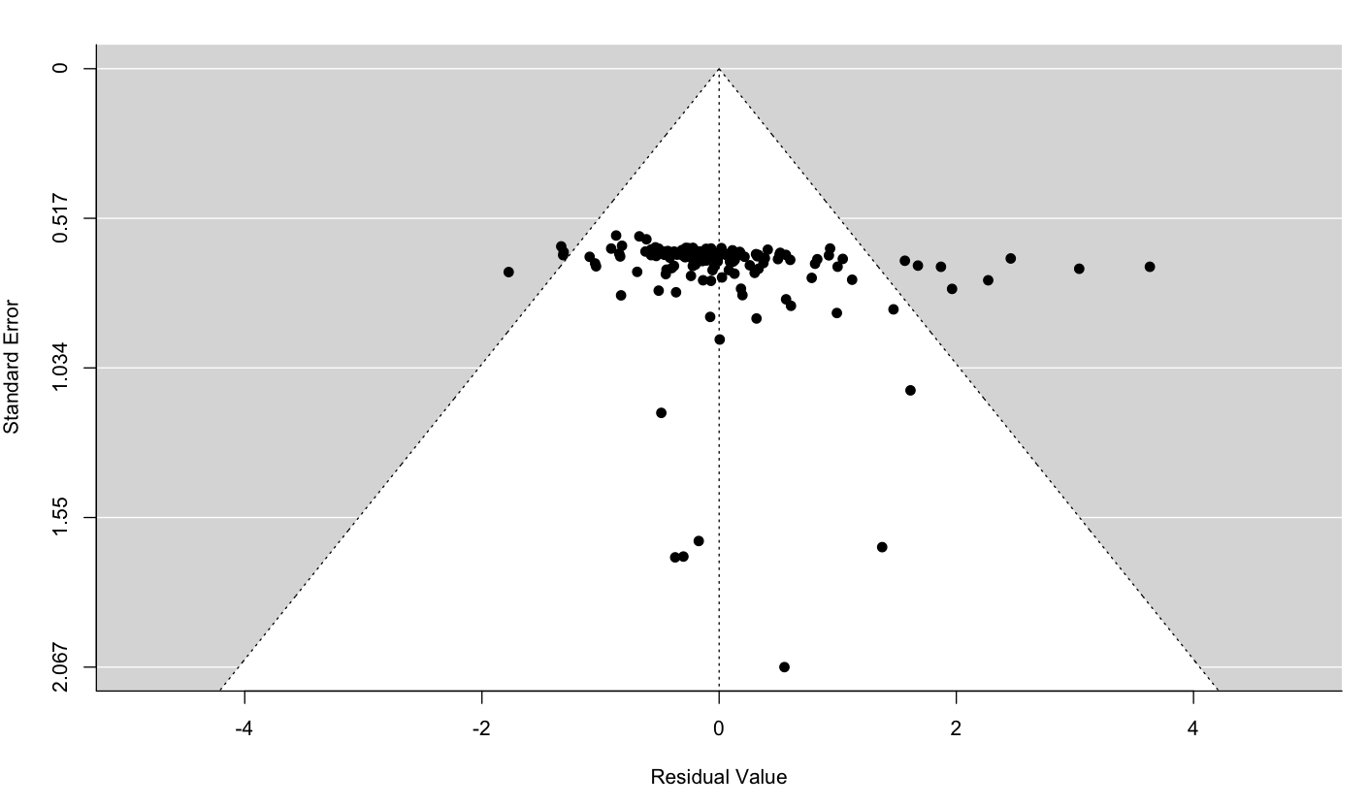
Fig. S1. Funnel plot for the model including background nutrients. What is residual value here? Effect size?? What’s your interpretation of this funnel plot?

Results
Our systematic literature review narrowed from 1,429 to 37 studies after screening, which contributed 180 individual effect sizes after screening each article (Fig. S1). These included reports were fairly well spread across latitudes, but there was a bias towards studies conducted in North America (Fig 2A). The majority of effect sizes were drawn from symbiotic cnidarians as the primary producer (n = 55), which represented corals, endosymbionts, and a single anemone. Phytoplankton (n = 53) were comprised of both diatoms and dinoflagellates, while vascular plants (n = 45) were primarily seagrasses, in addition to a cordgrass and mangrove species. Algae (n = 27) were represented by green, red, and brown fleshy and turf algae, in addition to a community of calcified algae (Table S3). The responses of primary producers to provisioning were measured in a number of ways including growth, density, percent cover, biomass, photosynthesis (Table S4). Unstocked field experiments (i.e, the most natural design) constituted the majority of experimental designs (47% of effect sizes), but all categories were well represented (7 - 47% of the total sample), with the exception of field experiments where both the consumer and producer were stoked (5%). Animals used in provisioning experiments were primarily sessile invertebrates (n = 109) comprised of bivalves, sponges, and a single hydroid species. Vertebrates (n = 55) were represented by fishes and communities of birds, while mobile invertebrates (n = 19), which were primarily sea cucumbers, also included jellies and a limpet (Table S5). Seagrass provisioned by mollusks (18% of effect sizes), followed by phytoplankton provisioned by mollusks (16%) and coral provisioned by fishes (16%) were the most common combinations of primary producers and consumers (Fig. 2B).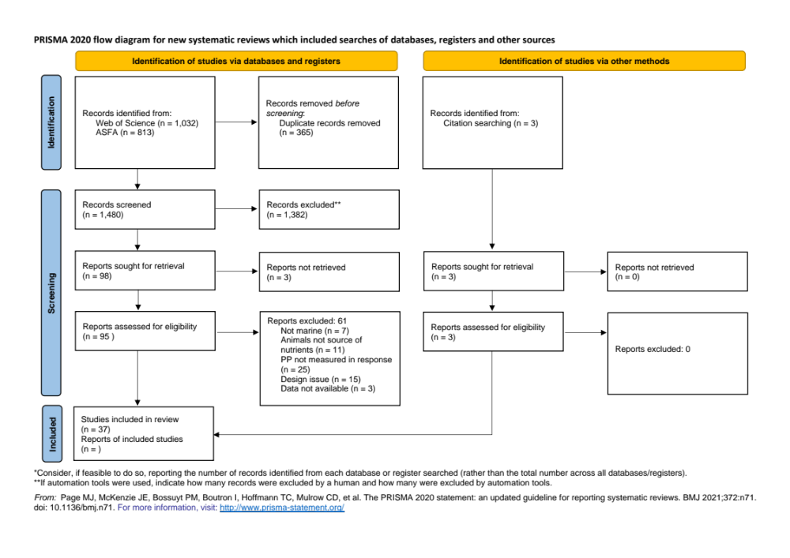
Figure S2: PRISMA diagram

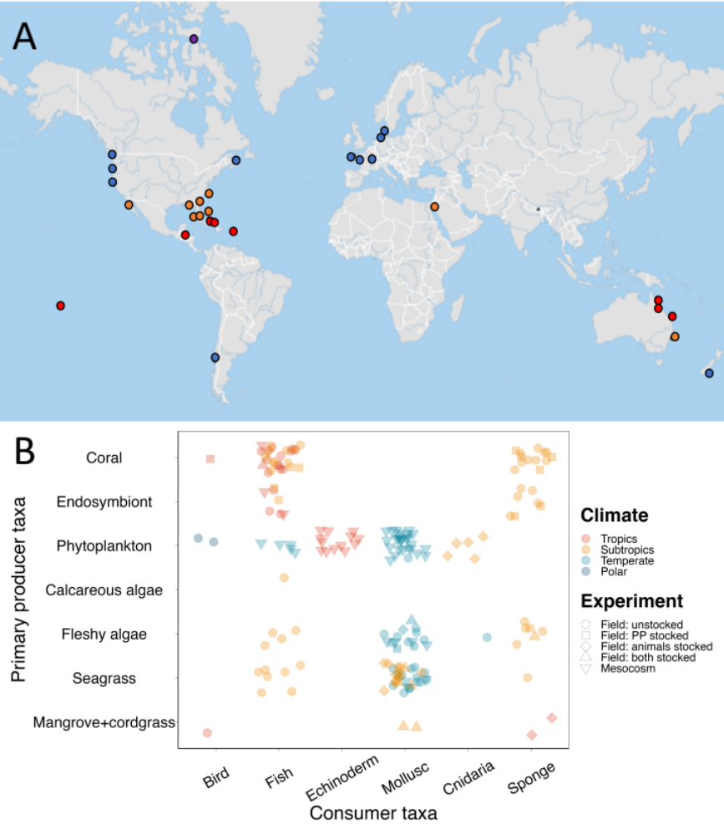
Figure 2. A) Geographical range of included studies, B) Primary producer group vs consumer group vs climate region.

Table S3: Complete list of primary producers included in this meta-analysis. For rows with NA for family, genus and species the producer was considered at the community level and could not be captured by a single family or genus.
Group | Family | Genus | Species | n
Algae | Anadyomenaceae | Microdictyon | marinum | 1
Algae | Bangiaceae | Porphyra | perforata | 4
Algae | Dictyotaceae | Dictyota | spp. | 1
Algae | Ectocarpaceae | Ectocarpus | siliculosus | 6
Algae | Endocladiaceae | Endocladia | muricata | 1
Algae | Fucaceae | Pelvetiopsis | limitata | 1
Algae | Halymeniaceae | Prionitis | lanceolata | 1
Algae | Laminariaceae | Macrocystis | pyrifera | 1
Algae | Phyllophoraceae | Mastocarpus | papillatus | 1
Algae | Rhodomelaceae | Odonthalia | floccosa | 1
Algae | NA | NA | NA | 9
Coral | Acroporidae | Acropora | cervicornis | 1
Coral | Acroporidae | Acropora | formosa | 1
Coral | Acroporidae | Acropora | palmata | 2
Coral | Acroporidae | Porites | furcata | 2
Coral | Actiniidae | Entacmaea | quadricolor | 1
Coral | Pocilloporidae | Pocillopora | damicornis | 3
Coral | Pocilloporidae | Pocillopora | damicornus | 6
Coral | Pocilloporidae | Pocillopora | eydouxi | 2
Coral | Poritidae | Porites | furcata | 7
Coral | Poritidae | Porites | porites | 1
Coral | Siderastreidae | Siderastrea | radians | 8
Coral | Symbiodiniaceae | Symbiodinium | spp. | 4
Coral | NA | NA | NA | 17
Phytoplankton | Bacillariaceae | Nitzschia | acicularis | 2
Phytoplankton | Bacillariaceae | Nitzschia | closterium | 2
Phytoplankton | Bacillariaceae | Nitzschia | gandersheimiensis | 2
Phytoplankton | Brachidiniaceae | Karenia | mikimotoi | 2
Phytoplankton | Catenulaceae | Amphora | sp | 2
Phytoplankton | Chaetocerotaceae | Chaetoceros | gracilis | 2
Phytoplankton | Chaetocerotaceae | Chaetoceros | sp | 2
Phytoplankton | Chattonellaceae | Heterosigma | akashiwo | 3
Phytoplankton | Chlorodendraceae | Tetraselmis | suecica | 2
Phytoplankton | Entomoneidaceae | Entomoneis | alata | 2
Phytoplankton | Naviculaceae | Haslea | ostrearia | 2
Phytoplankton | Ostreopsidaceae | Alexandrium | catenella | 2
Phytoplankton | Ostreopsidaceae | Alexandrium | minutum | 2
Phytoplankton | Skeletonemataceae | Skeletonema | costatum | 2
Phytoplankton | NA | NA | NA | 24
Plants | Hydrocharitaceae | Thalassia | testudinum | 15
Plants | Poaceae | Spartina | alterniflora | 2
Plants | Rhizophoraceae | Rhizophora | mangle | 3
Plants | Zosteraceae | Zostera | marina | 23
Plants | NA | NA | NA | 2

Table S4: 78 measured growth rate and 102 didn’t standardize to a unit of time. From all reported effect sizes, they measured the following to characterize primary producer performance.
Metric | n | Description/examples
density | 55 | Density of phytoplankton, seagrass shoots, and coral skeletal density
percent cover | 22 | Percent cover of algae and coral
biomass | 21 | Biomass of aboveground and belowground plant matter, algae, phytoplankton, seagrass, coral tissue, and carbon
photosynthesis | 20 | Production of oxygen by phytoplankton and seagrass
length | 12 | Length of seagrass leaves and shoots, and coral branches/nubbins
buoyant weight | 9 | Buoyant weight of corals
dry weight | 9 | Dry weight of seagrass shoots and coral tissue
Chl a | 8 | Concentration of chlorophyll A in water, tissue, and algae.
area | 7 | Area of algae thallus, anemone basal disk, coral surface, seagrass leaves and shoot coverage, and clonal outgrowth of cordgrass.
circumference | 6 | Coral circumference
count | 6 | Seagrass leaf/shoot count and kelp blade production.
protein | 3 | Tissue protein in corals
volume | 1 | Coral volume
width | 1 | Seagrass leaf width

Table S5: Species of animals used. For rows with NA for family, genus and species the producer was considered at the community level and could not be captured by a single family or genus.
Group | Family | Genus | Species | n
Bird | NA | NA | NA | 4
Fish | Haemulidae | Haemulon | spp. | 11
Fish | Haemulidae | NA | NA | 7
Fish | Moronidae | Dicentrarchus | labrax | 3
Fish | Pomacentridae | Amphiprion | bicinctus | 1
Fish | Pomacentridae | Dascyllus | aruanus | 13
Fish | Pomacentridae | NA | NA | 1
Fish | Salmonidae | Salmo | salar | 2
Fish | NA | NA | NA | 13
Echinoderm | Holothuriidae | Holothuria | atra | 1
Echinoderm | NA | NA | NA | 12
Mollusc | Calyptraeidae | Crepidula | fornicata | 1
Mollusc | Mytilidae | Geukensia | demissa | 2
Mollusc | Mytilidae | Modiolus | americanus | 7
Mollusc | Mytilidae | Mytilus | californianus | 11
Mollusc | Mytilidae | Mytilus | chilensis | 2
Mollusc | Mytilidae | Mytilus | edulis | 24
Mollusc | Ostreidae | Magallana | gigas | 27
Mollusc | Veneridae | Mercenaria | mercenaria | 3
Cnidaria | Campanulariidae | Obelia | geniculata | 1
Cnidaria | Catostylidae | Catostylus | mosaicus | 5
Sponge | Aplysinidae | Aplysina | cauliformis | 1
Sponge | Chalinidae | Haliclona | implexiformis | 1
Sponge | Halichondriidae | Halichondria | melanadocia | 1
Sponge | Tedaniidae | Tedania | ignis | 1
Sponge | NA | NA | NA | 25

Meta-regression reporting
When we compared each of the models containing experimental design, primary producer taxa, and one of the correlated variables, i.e. absolute latitude, temperature, or background nutrients, against a null model, the model containing background nutrients had strongest support, but there was support for all three models with a correlated variable (1 < Δ𝑖 < 3), and little support for the null model (Δ𝑖 > 6, Table 1). Therefore, we report results from all three models.

Table 1: AIC comparison of models. Moderators included in each model (ED = experimental design, PPG = primary producer group, RE = random effect), K is the number of parameters included in the model, AIC is the Akaike’s Information Criterion for each model, ΔAIC is the AIC for each model minus the AIC from the best model, and AIC weight is the calculated weight of each model
Moderators | K | AIC | ΔAIC | AIC weight
Background nutrients, ED, PPG, RE | 11 | 374.18 | 0 | 0.54
Temperature, ED, PPG, RE | 11 | 375.74 | 1.56 | 0.25
Absolute latitude, ED, PPG, RE | 11 | 376.20 | 2.01 | 0.20
RE | 3 | 380.78 | 6.59 | 0.02

Background nutrients model
Overall, we found a positive effect of animal-provisioned nutrients on primary productivity (log-transformed response ratio ± SE; 0.45± 0.16, p = 0.007), with producers growing nearly 3 times more, on average, under provisioned than control conditions. This estimate represents the intercept of the model, taken as the effect of animal-provisioning at a mean level of background nutrients on algae in unstocked field experiments. There was no statistical evidence for the slightly positive effect of background nutrients on the effect of animal-provisioned nutrients on primary productivity (0.11 ± 0.07, p = 016; Fig. 3, Table S6). The test of moderators was not statistically significant (F_{8,171} = 1.42, p = 0.19), and there was still a significant amount of residual heterogeneity unexplained by the model (QE₁₇₁ = 3025.31, p < 0.001). The response ratio of all experimental designs, except field experiments with stocked producers, was consistently positive (no overlap of 95% CI with zero, Fig 3). Between levels of this moderator, the responses of primary producers in unstocked field experiments (0.45 ± 0.16; provisioned producers grew 280% more than controls) were not significantly different than those in field experiments with stocked producers (0.32 ± 0.22; 208%), stocked consumers (0.82 ± 0.22; 664%) or mesocosms (0.58 ± 0.20; 376%). However, there was a larger effect of provisioning on primary productivity in field experiments stocked consumers and producers (1.11 ± 0.32, 1274%; Fig. 3). For primary producer taxa algae responded significantly positively to provisioning (no overlap of 95% CI with zero), but coral, phytoplankton, and plants did not respond significantly (Fig 3). Algae (0.45 ± 0.16; 280% increase) and corals (0.37 ± 0.21; 234%) showed the largest responses to animal-provisioned nutrients. Phytoplankton (0.09 ± 0.23; 123%) and vascular plants (0.11 ± 0.19; 129%) showed significantly smaller and more uncertain responses to provisioning.

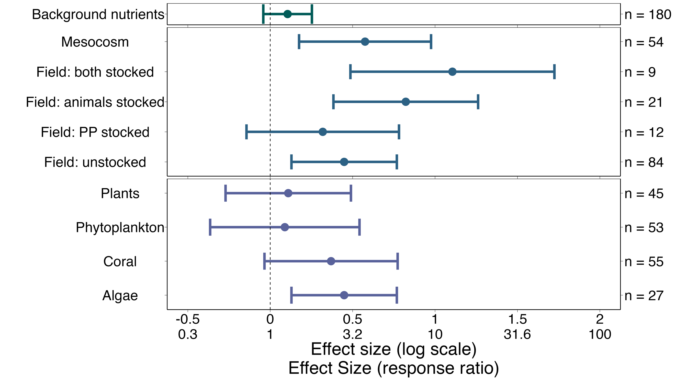
Fig. 3. Effect of background nutrients, experimental design, and primary producer group on primary producers. Effect sizes shown in log-transformed ratios of means and as back-transformed ratios of means. An effect size of 0 on the log scale or 1 on the ratio scale means the primary producer grew the same with and without nutrient addition. Effect sizes to the right of the dotted line indicate positive responses to provisioning, and effect sizes to the left indicate negative responses. Field experiments were split based on whether the researchers set the density of the primary producer (PP stocked), consumer (animals stocked), both, or neither (unstocked). Plants include seagrasses and mangroves, phytoplankton include micro algae, coral includes measurements of both corals and coral endosymbionts, and algae includes fleshy and crustose algae. Effect sizes are surrounded by 95% confidence intervals derived from the three-level mixed effects model including background nutrients, experimental design, and primary producer group as moderators. Sample sizes within each group are shown to the right of the effect sizes.

Table S6: Model output for background nutrients model
 | estimate | SE | t-value | df | p-value
Intercept | 0.45 | 0.16 | 2.75 | 171 | 0.0066
Nut_stand | 0.11 | 0.075 | 1.41 | 171 | 0.16
Natural2 | -0.13 | 0.24 | -0.55 | 171 | 0.58
Natural3 | 0.37 | 0.22 | 1.67 | 171 | 0.09
Natural4 | 0.66 | 0.32 | 2.081 | 171 | 0.039
Natural5 | 0.13 | 0.20 | 0.62 | 171 | 0.54
pp_groupCoral | - 0.079 | 0.21 | -0.39 | 171 | 0.70
pp_groupPhytoplankton | - 0.36 | 0.23 | -1.56 | 171 | 0.12
pp_groupPlants | -0.34 | 0.19 | -1.75 | 171 | 0.082

Latitude and temperature models
We also found an overall positive effect of nutrient provisioning in the model including absolute latitude (0.51 ± 0.16, p = 0.0015). However, there was no evidence that the effect of nutrient provisioning varies with absolute latitude (-0.01 ± 0.08, p = 0.77; Fig. S3, Table S7). There was no evidence of differences between subgroups (F_{8, 171} = 1.19, p = 0.31), and a significant amount of unexplained residual heterogeneity (QE₁₇₁ = 2971.59, p < 0.001).
The model including temperature also showed an overall positive effect of nutrient provisioning overall (0.49 ± 0.16, p = 0.0024), but we found no evidence that the effect of provisioned nutrients varies with temperature (-0.05 ± 0.07, p = 0.48; Fig. S4, Table S8). The test for moderators was not significant (F_{8,171} = 1.26, p = 0.27), but there was still a significant amount of unexplained residual heterogeneity QE₁₇₁ = 3013.21, p < 0.001).
For both the model with latitude and that with temperature, the differences between levels of the categorical moderators (i.e., experimental design and primary producer taxa) were roughly of the same in magnitude and significance as in the model that included background nutrients (Tables S6, S8, S9, Fig S7, S8).
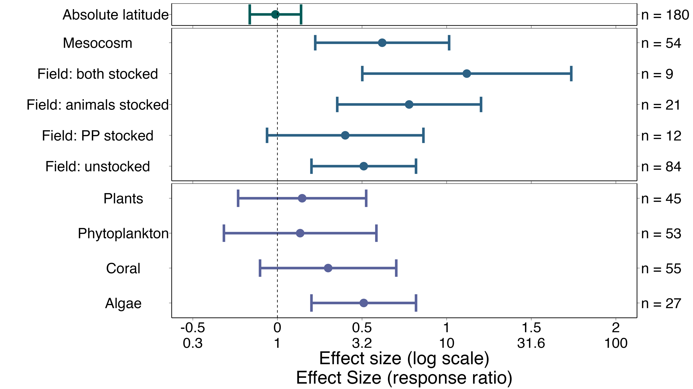
Figure S3. Effect sizes from absolute latitude model

Table S7: Model output for latitude model
 | estimate | SE | t-value | df | p-value
Intercept | 0.51 | 0.16 | 3.24 | 171 | 0.0015
Lat_stand | -0.012 | 0.077 | -0.15 | 171 | 0.88
Natural2 | -0.11 | 0.24 | -0.46 | 171 | 0.64
Natural3 | 0.27 | 0.22 | 1.24 | 171 | 0.22
Natural4 | 0.61 | 0.32 | 1.93 | 171 | 0.055
Natural5 | 0.11 | 0.21 | 0.54 | 171 | 0.59
pp_groupCoral | -0.21 | 0.21 | -1.024 | 171 | 0.31
pp_groupPhytoplankton | -0.38 | 0.23 | - 1.63 | 171 | 0.10
pp_groupPlants | -0.36 | 0.19 | -1.89 | 171 | 0.061

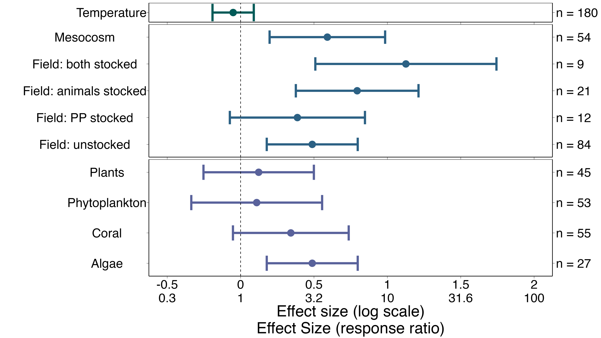
Figure S4: Effect sizes from temperature model

Table S8. Model output for temperature model
 | estimate | SE | t-value | df | p-value
Intercept | 0.49 | 0.16 | 3.09 | 171 | 0.0024
temp_stand | -0.051 | 0.071 | -0.72 | 171 | 0.48
Natural2 | -0.10 | 0.23 | -0.43 | 171 | 0.67
Natural3 | 0.31 | 0.21 | 1.44 | 171 | 0.15
Natural4 | 0.64 | 0.31 | 2.027 | 171 | 0.044
Natural5 | 0.10 | 0.20 | 0.51 | 171 | 0.61
pp_groupCoral | -0.15 | 0.20 | -0.72 | 171 | 0.47
pp_groupPhytoplankton | -0.38 | 0.23 | -1.66 | 171 | 0.098
pp_groupPlants | -0.36 | 0.19 | -1.90 | 171 | 0.059

Discussion
Overall, we found a consistently positive effect of animal-provisioned nutrients on the growth and performance of primary producers across studies. This shows that consumers are generally able to bolster primary productivity through fertilization, thus supporting bottom-up processes. However, we did not find support for the hypothesis that consumer-mediated nutrient cycling (CNC) has a larger effect on productivity in tropical, oligotrophic waters. We did not find a relationship between absolute latitude and the effect of CNC on productivity, suggesting the effect doesn’t vary between tropical and temperate waters. When we examined background nutrient availability and temperature, two additional variables that might capture the greater growth benefit to producers in the tropics, we found no effect of these variables either. We found that algae respond the strongest to nutrient provisioning, and experimental design didn’t usually alter effect size (although field experiments with stocked producers showed weaker and less consistent responses to provisioning). Large amounts of heterogeneity were unexplained by our models, suggesting effects of processes not included in our models or high levels of natural variability. These results taken together suggest the effect of CNC on productivity is driven by smaller scale processes than the overall latitude or topicalization of regions.

Not only did we find no significant effect of absolute latitude on the effect of CNC on productivity, but our estimate for the relationship was slightly negative; our hypothesis was not only unsupported, but potentially backwards. This is in direct conflict with conventional wisdom, which suggest that CNC would have the greatest effect at low, nutrient poor latitudes (Allgeier et al., 2017; Atkinson et al., 2017). However, we are not the first to find a similar effect of fertilization between tropical and temperate regions. (Gruner et al., 2008) found similar impacts of fertilization on productivity between temperate rocky reefs and coral reefs. –need more here--

One of the lines of reasoning for believing CNC is most important in the tropics is due to the low external nutrient input into these ecosystems. In tropical waters, external nutrients from run-off, atmospheric fixation, and upwelling provide less than X% (CITE). Conversely, some temperate regions receive massive amounts of nitrogen from upwelling and run-off (Pawlowicz, 2017). However, temperate regions also experience nutrient limitation, due to reduced flow (ie tidepools, (Bracken, 2004) or periods of inactivity with regards to upwelling (McPhee-Shaw et al., 2007). Under these conditions of nutrient limitation, we see producers respond strongly to the effect of CNC (Bracken et al., 2007). Interestingly, in the same region researchers sought to quantify the effect of CNC on productivity even when both flow and nutrient availability is high, and still found strong effects of nutrient provisioning (Aquilino et al., 2009). Therefore, if we assume the effect of CNC is high in the tropics because of low nutrients, we shouldn’t be surprised to see large effects of CNC in temperate areas which also undergo nutrient limitation. Further, even when nitrate-replete, high flow conditions, we still see large effects of CNC. Therefore, perhaps it is not the level of external nutrient input that determines the effect of CNC on producers.

The ability of consumers to significantly fertilize producers with their excretions, even in nitrate-replete water, is likely due to the increased fertilization capabilities of ammonium relative to nitrate. Many consumers excrete ammonium as metabolic waste, and their egestion can enrich the organic nitrogen content of sediment, which microbes then remineralize as ammonium. Ammonium is a positively charged ion, which can be absorbed through passive or facilitated uptake, and active uptake (Lobban and Harrison, 1994). Conversely, nitrate, which is negatively charged, must move across the electrochemical potential gradient, and thus requires active transport. This is supported by uptake studies that find ammonium update generally increases linearly with increasing concentrations, while the uptake of nitrate saturates (Phillips and Hurd, 2004). Further, once nitrate is inside the cell, it requires conversion to ammonium before it can be assimilated as amino acids. Therefore, increases in ammonium may bolster productivity even in the presence of abundant nitrate, as ammonium is less energetically costly to uptake and assimilate than nitrate.

While we didn’t find a significant relationship between background nutrient availability and the effect of CNC on productivity, the observed relationship was positive, suggesting that producers may respond stronger to CNC in higher nutrient waters. While this is at odds with the conventional wisdom that CNC would have higher impacts in lower nutrient water, this may be in line with plant physiology. Past exposure to nutrients can influence future uptake rates, and some plants grown in high nitrogen conditions increased their ability to uptake ammonium (Zalamea et al., 2016). In fertilization experiments, sometimes plots are taken over by producers with larger potential for uptake and utilization of these nutrients (Gough et al., 2016), so it follows that producer communities exposed to high nutrient availability may be comprised of species that are able to uptake and use nutrients well. When we compare the surge uptake capacities of different seaweeds, we see that giant kelp from nutrient-replete waters are able to quickly uptake and store large amounts of nitrogen (Cedeno et al., 2021). Therefore, it’s possible that CNC may actually produce stronger effects in nutrient-replete waters given the physiology of the producers found in these ecosystems.

Although we found that CNC did not have a larger effect in the tropical vs temperate marine ecosystems, our meta-analysis was unsuited to answer whether or not it’s more important in the tropics. Vitousek et al. (2010) distinguishes between limiting nutrients which can increase growth and ultimate nutrients, which transform entire environments. In the Artic, the addition of nitrogen and phosphorus were found to transform ecosystems, increasing not only NPP but also altering food webs, geophysical processes, and more (Gough et al., 2016). Nitrogen may be an ultimate nutrient in oligotrophic ecosystems. Artificial reefs, which attract coral reef fishes and their excretions, start positive feedback loops which can create novel ecosystems where landscapes were otherwise bare (Layman et al., 2016). Fish pee may be an ecosystem stabilizer; it once supported the growth of corals, but now fertilizes an alternate stable state: fleshy algae (Allgeier et al., 2017). We see the impact of this resource not only increasing primary productivity, but completely transforming ecosystems in tropical ecosystems. While CNC may increase diversity of producer communities (Bracken and Stachowicz, 2006), we don’t see as dramatic transformations in temperate areas, with the exception of anthropogenic eutrophication. CNC may assist in supporting kelp growth once spring upwelling ceases, but it’s often thought of and considered as an aid to upwelling, not the primary source of nutrients (Brzezinksi et al., 2013). Therefore, which CNC doesn’t produce larger effects in the tropics, it may still be a more important process compared to temperate ecosystems.

We were surprised to discover how few studies (X/X) provided data on the environmental conditions under which experiments were run. We initially attempted to quantify the level of provisioning provided by consumers, but this data was often not available. More surprising was the absence of ambient nutrient availability. We suggest that future research on CNC report the ambient nitrate and ammonium concentrations in uM or other standardized units to facilitate comparisons to other studies. The lack of data necessitated estimating both background and temperature data for a number of studies, which weakened our study. However, given the scale of magnitude of variance in these variables (X – X uM of nitrogen, X- X degrees in temperature), we are confident that our estimates roughly described low nitrogen sites as low, and high nitrogen sites as high fairly well. Our studies were strongly biased towards North American and European countries, which was likely a combined effect of the databases used in our literature search and the publication bias towards English speaking countries. More data from the global south would have improved our analyses.

In conclusion, we found a positive effect of consumer-mediated nutrient cycling on primary productivity, providing further support for this process as an important contributor to bottom-up processes. However, we did not find evidence to support the conventional wisdom that CNC should have larger effects on producers in tropical regions when we examined absolute latitude, ambient nutrient availability, and temperature. Therefore, we suggest that the impact of CNC may not vary on such broad scales and is instead controlled by finer scale variables. As humans continue to reduce and redistribute animal biomass worldwide, alter nutrient cycles through eutrophication, and threaten oceanographic processes through climate change it remains important to understand the role of animals in supporting primary productivity. Consumers in temperate, nutrient-replete waters may be more important for bottom-up processes than initially thought and more research should investigate their role.

SUPPLEMENT
Full search string
(ammon* OR nitrog* OR phosph* OR nutrient*) AND (excret* OR egest* OR mutual* OR symbio* OR subsid* OR consumer-mediat*) AND (coral* OR kelp* OR alga* OR macroalgae OR microalgae OR phytoplankton OR zooxanthell* OR primary prod* OR seagrass* OR sea grass* OR seaweed* OR mangrove*) AND (reef OR subtidal OR intertidal OR coast* OR marine OR benthic OR coral OR kelp) AND (grow* OR grew OR biomass OR abundance OR weight).

References

